AGILE DATABASE -ASSIGNMENT
DATA CLEANING

#PROJECTS TABLE
SELECT *
FROM PROJECTS
WHERE `PROJECT ID` IS NULL
OR `START DATE` IS NULL
OR `END DATE` IS NULL
OR `PROJECT LEAD ID` IS NULL
OR `STATUS` IS NULL
OR `DEPT ID` IS NULL;

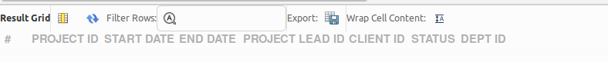

# UPDATE PROJECTS -STATUS COLUMN
SET STATUS =
CASE
WHEN UPPER(STATUS) IN ('NOT STRTD','NT STARTED','NOT START','NOT STARTED','NOTSTARTED','NT STARTED','NOT STRTD')
THEN 'NOT STARTED'

WHEN UPPER(STATUS) IN ('IP','IN PROGRES','IN PROGRESS','INPROGRESS','IN PROG','INPROG','IN PROGRES')
THEN 'IN PROGRESS'

WHEN UPPER(STATUS) IN ('ON HOLD','ONHOLD','ON HOLD ')
THEN 'ON HOLD'

WHEN UPPER(STATUS) IN ('COMP','COMPETED','COMPLETD','COMPLETED','COMPLETE','COMPLET')
THEN 'COMPLETED'

ELSE STATUS
END;

#START DATE
UPDATE PROJECTS
SET `START DATE` = CASE
-- 1. Handle long format: "Tuesday, July 7, 2025 at 12:00:00 AM"
-- This extracts just "July 7, 2025"
WHEN `START DATE` LIKE '%,%at%' THEN
TRIM(SUBSTRING_INDEX(SUBSTRING_INDEX(`START DATE`, ' at', 1), ',', -1))

-- 2. Handle timestamp format: "3/16/2025 0:00:00"
WHEN `START DATE` LIKE '%:%' THEN
TRIM(SUBSTRING_INDEX(`START DATE`, ' ', 1))

-- 3. Otherwise, just trim spaces
ELSE TRIM(`START DATE`)
END;

UPDATE PROJECTS
SET `START DATE` = CASE
-- 1. Already correct (YYYY-MM-DD) -> Leave it
WHEN `START DATE` REGEXP '^[0-9]{4}-[0-9]{2}-[0-9]{2}$' THEN `START DATE`

-- 2. Format: "3/16/2025"
WHEN `START DATE` LIKE '%/%' THEN
STR_TO_DATE(`START DATE`, '%m/%d/%Y')

-- 3. Format: "12-Apr-2024"
WHEN `START DATE` LIKE '%-%' AND `START DATE` NOT REGEXP '^[0-9]{4}' THEN
STR_TO_DATE(`START DATE`, '%d-%b-%Y')

-- 4. Format: "July 28, 2022"
WHEN `START DATE` REGEXP '^[A-Za-z]+ [0-9]+, [0-9]+$' THEN
STR_TO_DATE(`START DATE`, '%M %e, %Y')

ELSE `START DATE`
END
WHERE `START DATE` IS NOT NULL;

#END DATE
UPDATE PROJECTS
SET `END DATE` = CASE
-- Matches: "Tuesday, July 7, 2026 at 12:00:00 AM" -> Extracts: "July 7, 2026"
WHEN `END DATE` LIKE '%,%at%' THEN
TRIM(SUBSTRING_INDEX(SUBSTRING_INDEX(`END DATE`, ' at', 1), ',', -2))

-- Matches: "3/16/2025 0:00:00" -> Extracts: "3/16/2025"
WHEN `END DATE` LIKE '%:%' THEN
TRIM(SUBSTRING_INDEX(`END DATE`, ' ', 1))

ELSE `END DATE`
END;

-- 4. Final Conversion to SQL Date Format (YYYY-MM-DD)
UPDATE PROJECTS
SET `END DATE` = CASE
-- Slash format: 3/16/2025
WHEN `END DATE` LIKE '%/%' THEN STR_TO_DATE(`END DATE`, '%m/%d/%Y')

-- Dash format: 28-Jul-2023
WHEN `END DATE` LIKE '%-%' AND `END DATE` NOT LIKE '20%' THEN STR_TO_DATE(`END DATE`, '%d-%b-%Y')

-- Text format: July 7, 2026
WHEN `END DATE` LIKE '%,%' THEN STR_TO_DATE(`END DATE`, '%M %e, %Y')

ELSE `END DATE`
END;

#DEPT ID
SET `DEPT ID` = CASE
WHEN `DEPT ID` IN ('FINANCE', 'FIANCE', 'FIN') THEN 'FIN'
WHEN `DEPT ID` IN ('HUMMAN RESOURCE', 'HUMAN RESOURCE', 'HR') THEN 'HR'
WHEN `DEPT ID` IN ('SOFTWRE DEVLPMNT', 'SOFT. DEV', 'SD') THEN 'SD'
WHEN `DEPT ID` IN ('SS') THEN 'SS'
WHEN `DEPT ID` IN ('SM') THEN 'SM'
ELSE `DEPT ID`
END;

#PROJECT LEAD ID
UPDATE PROJECTS
SET `PROJECT LEAD ID` = UPPER(TRIM(REPLACE(REPLACE(`PROJECT LEAD ID`, '-', ''), ' ', '')));
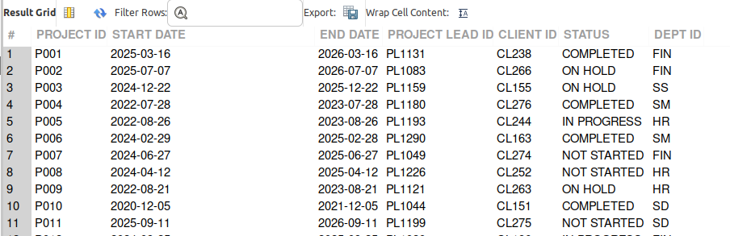

#SPRINT TABLE
#sprint id
UPDATE SPRINT
SET `SPRINT_ID` = TRIM(UPPER(`SPRINT_ID`));

UPDATE SPRINT
SET SPRINT_ID = REPLACE(SPRINT_ID, 'SPRINT_ID', '')
WHERE SPRINT_ID LIKE 'SPRINT_ID%';

UPDATE SPRINT
SET SPRINT_ID = INSERT(SPRINT_ID, 4, 0, '-')
WHERE SPRINT_ID NOT LIKE '%-%' AND SPRINT_ID LIKE 'SPR%';

#START DATE
UPDATE SPRINT
SET `START DATE` = DATE_FORMAT(
STR_TO_DATE(`START DATE`,'%m/%d/%Y %H:%i:%s'),
'%Y-%m-%d'
)
WHERE `START DATE` LIKE '%:%';
UPDATE SPRINT
SET `START DATE` = REPLACE(`START DATE`,'/','-');
UPDATE SPRINT
SET `START DATE` = DATE_FORMAT(
STR_TO_DATE(`START DATE`,'%m/%d/%Y'),
'%Y-%m-%d'
)
WHERE `START DATE` NOT LIKE '%:%';
UPDATE SPRINT
SET `START DATE` = REPLACE(`START DATE`,'/','-');

UPDATE SPRINT
SET `START DATE` = DATE_FORMAT(
STR_TO_DATE(`START DATE`, '%m-%d-%Y'),
'%Y-%m-%d'
);

UPDATE SPRINT
SET `START DATE` = DATE_FORMAT(
STR_TO_DATE(`START DATE`, '%m-%d-%Y'),
'%Y-%m-%d'
)
WHERE `START DATE` NOT REGEXP '^[0-9]{4}-[0-9]{2}-[0-9]{2}$'; CHANGE TO END DATE

#END DATE
UPDATE SPRINT
SET `END DATE` = DATE_FORMAT(
STR_TO_DATE(`END DATE`,'%m/%d/%Y %H:%i:%s'),
'%Y-%m-%d'
)
WHERE `END DATE` LIKE '%:%';

UPDATE SPRINT
SET `END DATE` = REPLACE(`END DATE`,'/','-');

UPDATE SPRINT
SET `END DATE` = DATE_FORMAT(
STR_TO_DATE(`END DATE`,'%m/%d/%Y'),
'%Y-%m-%d'
)
WHERE `END DATE` NOT LIKE '%:%';

UPDATE SPRINT
SET `END DATE` = REPLACE(`END DATE`,'/','-');

UPDATE SPRINT
SET `END DATE` = DATE_FORMAT(
STR_TO_DATE(`END DATE`, '%m-%d-%Y'),
'%Y-%m-%d'
);

UPDATE SPRINT
SET `END DATE` = DATE_FORMAT(
STR_TO_DATE(`END DATE`, '%m-%d-%Y'),
'%Y-%m-%d'
)
WHERE `END DATE` NOT REGEXP '^[0-9]{4}-[0-9]{2}-[0-9]{2}$';

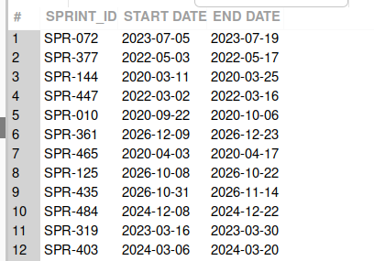

#TASK TABLE
#TICKET_ID
UPDATE TASK
SET TICKET_ID = UPPER(TICKET_ID);
SELECT DISTINCT TICKET_ID
FROM TASK
LIMIT 20;

SELECT TICKET_ID,COUNT(TICKET_ID) FROM TASK GROUP BY TICKET_ID HAVING COUNT(TICKET_ID)>1;
UPDATE TASK
SET `START DATE` = DATE_FORMAT(
STR_TO_DATE(`START DATE`, '%m/%d/%Y %H:%i:%s'),
'%Y-%m-%d'
)
WHERE `START DATE` LIKE '%:%';

#START DATE
SELECT TICKET_ID,COUNT(TICKET_ID) FROM TASK GROUP BY TICKET_ID HAVING COUNT(TICKET_ID)>1;
UPDATE TASK
SET `START DATE` = DATE_FORMAT(
STR_TO_DATE(`START DATE`, '%m/%d/%Y %H:%i:%s'),
'%Y-%m-%d'
)
WHERE `START DATE` LIKE '%:%';

UPDATE TASK
SET `START DATE` = SUBSTRING_INDEX(`START DATE`,' ',1);
SET SQL_SAFE_UPDATES=0;
use AGILEDB;
UPDATE TASK
SET `START DATE` = DATE_FORMAT(
STR_TO_DATE(`START DATE`, '%m/%d/%Y'),
'%Y-%m-%d'
)
WHERE `START DATE` LIKE '%/%';

#END DATE
UPDATE TASK
SET `END DATE` = DATE_FORMAT(
STR_TO_DATE(SUBSTRING_INDEX(`END DATE`, ' ', 1), '%m/%d/%Y'),
'%Y-%m-%d'
);

#STATUS
UPDATE TASK
SET STATUS =
CASE
WHEN LOWER(STATUS) REGEXP 'not|strt' THEN 'NOT STARTED'
WHEN LOWER(STATUS) REGEXP 'ip|progress|prgres|prgres' THEN 'IN PROGRESS'
WHEN LOWER(STATUS) REGEXP 'hold' THEN 'ON HOLD'
WHEN LOWER(STATUS) REGEXP 'comp' THEN 'COMPLETED'
ELSE STATUS
END;

#SPRINT ID
UPDATE TASK
SET `SPRINT ID` = UPPER(`SPRINT ID`);

#PRIORITY LEVEL
UPDATE TASK
SET `PRIORITY LEVEL` =
CASE
WHEN LOWER(REPLACE(`PRIORITY LEVEL`,' ','')) LIKE 'low%' THEN 'LOW'
WHEN LOWER(REPLACE(`PRIORITY LEVEL`,' ','')) LIKE 'med%' THEN 'MEDIUM'
WHEN LOWER(REPLACE(`PRIORITY LEVEL`,' ','')) LIKE 'hig%' THEN 'HIGH'
ELSE `PRIORITY LEVEL`
END;

#DIFFICULTY LEVEL
UPDATE TASK
SET `DIFFICULTY LEVEL` =
CASE
WHEN LOWER(REPLACE(`DIFFICULTY LEVEL`,' ','')) LIKE 'easy%' THEN 'EASY'
WHEN LOWER(REPLACE(`DIFFICULTY LEVEL`,' ','')) LIKE 'med%' THEN 'MEDIUM'
WHEN LOWER(REPLACE(`DIFFICULTY LEVEL`,' ','')) LIKE 'hrd%'
OR LOWER(REPLACE(`DIFFICULTY LEVEL`,' ','')) LIKE 'hard%' THEN 'HARD'
ELSE `DIFFICULTY LEVEL`
END;

#PROJECT ID
UPDATE TASK
SET `PROJECT ID` = UPPER(`PROJECT ID`);

#SUB-PROJECT ID
UPDATE TASK
SET `PROJECT ID` = UPPER(`SUB-PROJECT ID`);

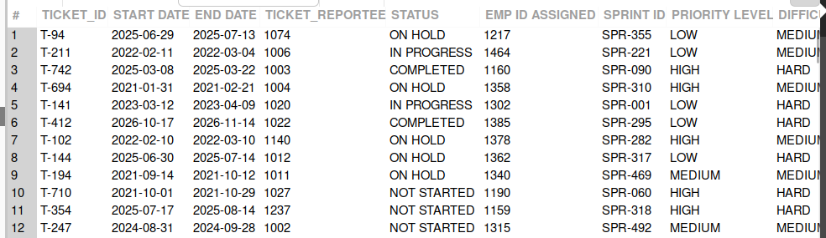

#DEPARTMENT
#DEPT NAME
UPDATE DEPARTMENT
SET `DEPT NAME` = UPPER(`DEPT NAME`);
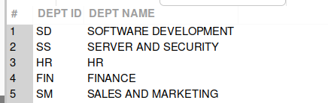

#EMPLOYEE GROWTH
CREATE TABLE `EMPLOYEE GROWTH` (
`GROWTH ID` INT PRIMARY KEY,
`EMP ID` INT,
`NEW DESIGNATION` VARCHAR(100),
`NEW DEPT ID` VARCHAR(24),
`NEW SALARY` DECIMAL(10,2),
`DATE` DATE,
`NEW MANAGER ID` INT

);

INSERT INTO `EMPLOYEE GROWTH`
(`GROWTH ID`, `EMP ID`, `NEW DESIGNATION`, `NEW DEPT ID`, `NEW SALARY`, `DATE`, `NEW MANAGER ID`)
VALUES
(1, 1001, 'HR', 'HR', 85000, '2024-01-10', 1001),
(2, 1002, 'SOFTWARE DEVELOPMENT', 'SD', 92000, '2024-02-15', 1005),
(3, 1003, 'FINANCE', 'FIN', 76000, '2024-03-20', 1008),
(4, 1004, 'SALES AND MARKETING','SM' , 88000, '2024-04-12', 1010),
(5, 1005, 'SERVER AND SECURITY', 'SS', 95000, '2024-05-18', 1012);

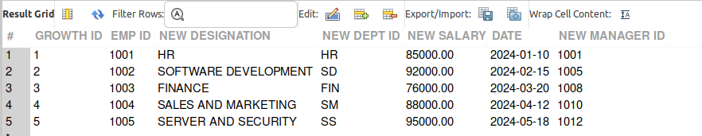

#EMPLOYEE TABLE
SELECT * FROM EMPLOYEE;

ALTER TABLE EMPLOYEE
RENAME COLUMN `EMP ID` TO EMP_ID,
RENAME COLUMN `HIRE DATE` TO HIRE_DATE,
RENAME COLUMN `LEAVING DATE` TO LEAVING_DATE,
RENAME COLUMN `HIRING MANAGER ID` TO HIRING_MANGER_ID,
RENAME COLUMN `JOINING DEPT ID` TO JOINING_DEPT_ID;

#Hire_date
UPDATE EMPLOYEE
SET `HIRE_DATE` =
DATE_FORMAT(
CASE

-- Format: January 12, 2019
WHEN `HIRE_DATE` REGEXP '^[A-Za-z]+ [0-9]{1,2}, [0-9]{4}$'
THEN STR_TO_DATE(`HIRE_DATE`, '%M %e, %Y')

-- Format: January 8 (missing year → assume 2019)
WHEN `HIRE_DATE` REGEXP '^[A-Za-z]+ [0-9]{1,2}$'
THEN STR_TO_DATE(CONCAT(`HIRE_DATE`, ' 2019'), '%M %e %Y')

-- Format: 1/14/2019
WHEN `HIRE_DATE` REGEXP '^[0-9]{1,2}/[0-9]{1,2}/[0-9]{4}$'
THEN STR_TO_DATE(`HIRE_DATE`, '%c/%e/%Y')

-- Format: YYYY-MM-DD
WHEN `HIRE_DATE` REGEXP '^[0-9]{4}-[0-9]{2}-[0-9]{2}$'
THEN STR_TO_DATE(`HIRE_DATE`, '%Y-%m-%d')

END
,'%Y%m%d');

ALTER TABLE EMPLOYEE
MODIFY HIRE_DATE DATE;

# leaving_date
UPDATE EMPLOYEE
SET `LEAVING_DATE` =
CASE
WHEN `LEAVING_DATE` IS NULL OR TRIM(`LEAVING_DATE`) = ''
THEN NULL

ELSE DATE_FORMAT(
CASE

-- Format: YYYY-MM-DD
WHEN `LEAVING_DATE` REGEXP '^[0-9]{4}-[0-9]{2}-[0-9]{2}$'
THEN STR_TO_DATE(`LEAVING_DATE`, '%Y-%m-%d')

-- Format: 5/8/2021
WHEN `LEAVING_DATE` REGEXP '^[0-9]{1,2}/[0-9]{1,2}/[0-9]{4}$'
THEN STR_TO_DATE(`LEAVING_DATE`, '%c/%e/%Y')

-- Format: 12/3/2020 0:00:00
WHEN `LEAVING_DATE` REGEXP '^[0-9]{1,2}/[0-9]{1,2}/[0-9]{4}'
THEN STR_TO_DATE(`LEAVING_DATE`, '%c/%e/%Y %H:%i:%s')

END
,'%Y%m%d')
END;

ALTER TABLE EMPLOYEE
MODIFY `LEAVING_DATE` DATE;

UPDATE EMPLOYEE
SET GENDER =
CASE

-- Male values
WHEN LOWER(TRIM(GENDER)) IN ('m','male')
THEN 'Male'

-- Female values
WHEN LOWER(TRIM(GENDER)) IN ('f','female')
THEN 'Female'

-- Empty values
WHEN GENDER IS NULL OR TRIM(GENDER) = ''
THEN NULL

-- Anything unexpected
ELSE NULL

END;

UPDATE EMPLOYEE
SET JOINING_DEPT_ID =
CASE

-- Convert NA to NULL
WHEN LOWER(TRIM(JOINING_DEPT_ID)) = 'na'
OR JOINING_DEPT_ID IS NULL
OR TRIM(JOINING_DEPT_ID) = ''
THEN NULL

-- Standardize HR
WHEN LOWER(TRIM(JOINING_DEPT_ID)) = 'hr'
THEN 'HR'

-- Standardize SS
WHEN LOWER(TRIM(JOINING_DEPT_ID)) = 'ss'
THEN 'SS'

-- Standardize FIN
WHEN LOWER(TRIM(JOINING_DEPT_ID)) = 'fin'
THEN 'FIN'

-- Standardize SM
WHEN LOWER(TRIM(JOINING_DEPT_ID)) = 'sm'
THEN 'SM'

-- Standardize SD
WHEN LOWER(TRIM(JOINING_DEPT_ID)) = 'sd'
THEN 'SD'

END;

SELECT * FROM EMPLOYEE;

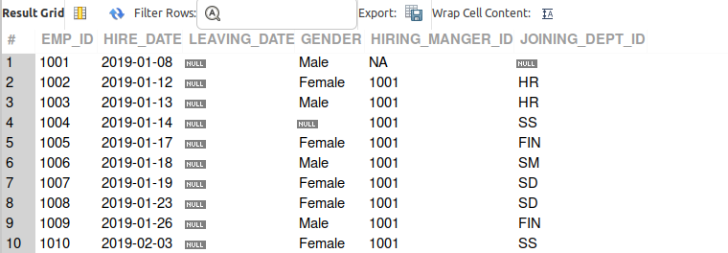

QUESTIONS
- Retrieve all projects that are not yet started.
SELECT *
FROM PROJECTS
WHERE STATUS = 'NOT STARTED';
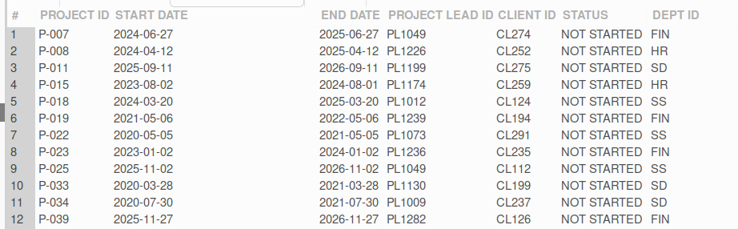
- List the names of all departments.
SELECT DISTINCT `DEPT NAME`
FROM DEPARTMENT;
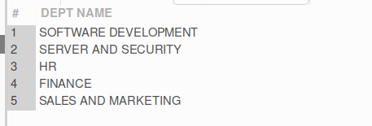
- Find all employees with their joining department IDs.
SELECT EMP_ID, JOINING_DEPT_ID
FROM EMPLOYEE;

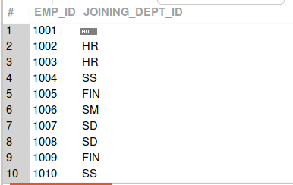
- Retrieve all tasks that are marked as "Completed."
SELECT *
FROM TASK
WHERE STATUS = 'COMPLETED';
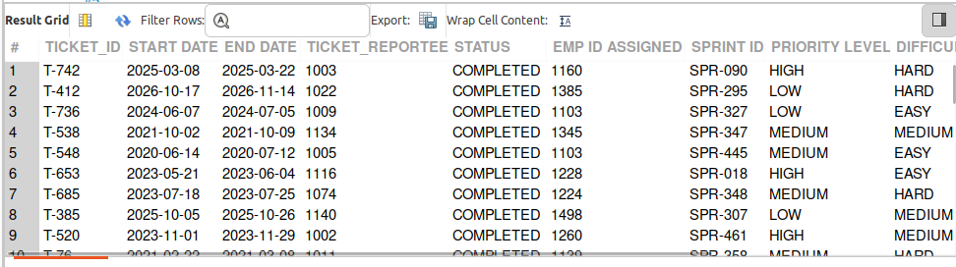
- List all sprints with their start and end dates.
SELECT `SPRINT ID`, `START DATE`, `END DATE`
FROM SPRINT;
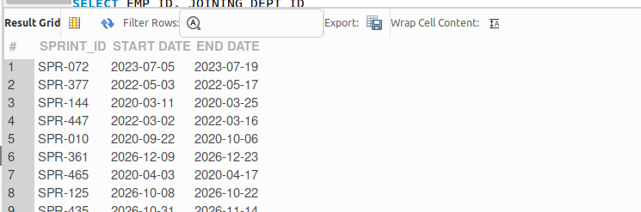

- Find the number of employees in each department.
SELECT JOINING_DEPT_ID, COUNT(*) AS employee_count
FROM EMPLOYEE
GROUP BY JOINING_DEPT_ID;

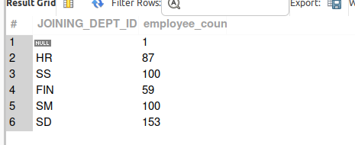
- Retrieve all sub-projects for a specific project.
SELECT `SUB PRO ID`, `PROJECT ID`, `START DATE`, `END DATE`, STATUS
FROM `SUB PROJECTS`
WHERE `PROJECT ID` = 'P-001';
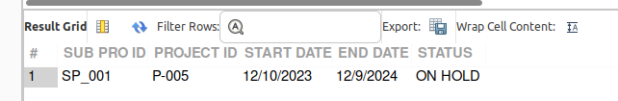

- List all projects handled by a specific project lead.
SELECT *
FROM PROJECTS
WHERE `PROJECT LEAD ID` = 'PL1131';
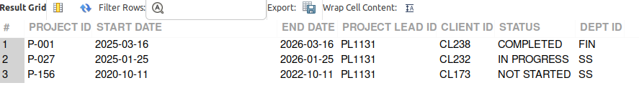

- Find the earliest start date for all projects.
SELECT MIN(START_DATE) AS EARLIEST_START_DATE
FROM PROJECTS;
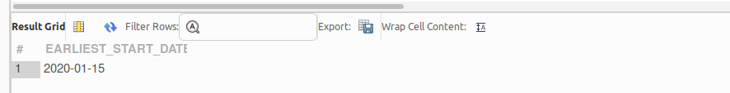
- Retrieve all tasks assigned to a specific employee.
SELECT *
FROM TASK
WHERE EMP_ID_ASSIGNED = 1160;
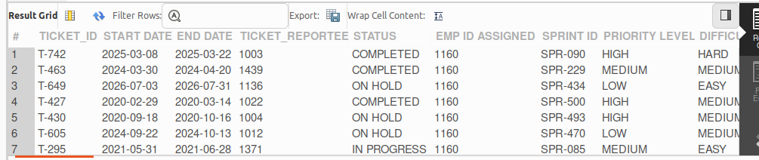

- Count the number of active (not completed) sub-projects.
SELECT COUNT(*) AS active_sub_projects
FROM SUB_PROJECTS
WHERE STATUS <> 'COMPLETED';

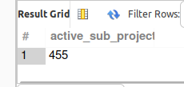

- List all projects and their statuses.
SELECT `PROJECT ID`, STATUS
FROM PROJECTS;

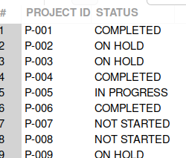

- Retrieve the total number of tasks for a specific sprint.
SELECT `SPRINT ID`, COUNT(*) AS total_tasks
FROM TASK
WHERE `SPRINT ID` = 'SPR-010'
GROUP BY `SPRINT ID`;
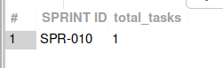

- List all clients associated with projects that are completed.
SELECT DISTINCT `CLIENT ID`
FROM PROJECTS
WHERE STATUS = 'COMPLETED';
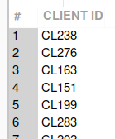
- Find all employees who joined in the year 2022.
SELECT EMP_ID, HIRE_DATE
FROM EMPLOYEE
WHERE YEAR(HIRE_DATE) = 2022;
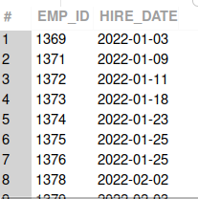
- List all departments and their associated project IDs.
SELECT D.`DEPT NAME`, P.`PROJECT ID`
FROM DEPARTMENT D
JOIN PROJECTS P
ON D.`DEPT ID` = P.`DEPT ID`;
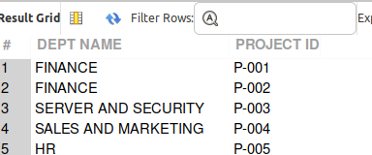
- Retrieve all tasks with a high priority level.
SELECT *
FROM TASK
WHERE `PRIORITY LEVEL` = 'HIGH';
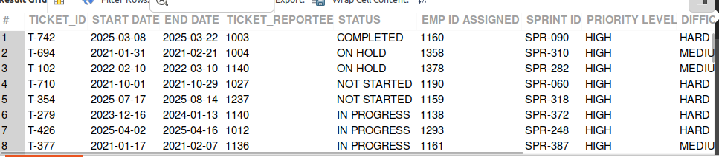

- Find all tasks assigned to employees hired in the last 3 years.
SELECT T.TICKET_ID,
T.`EMP ID ASSIGNED`,
E.HIRE_DATE
FROM TASK T
JOIN EMPLOYEE E
ON T.`EMP ID ASSIGNED` = E.EMP_ID
WHERE E.HIRE_DATE >= DATE_SUB(CURDATE(), INTERVAL 3 YEAR);
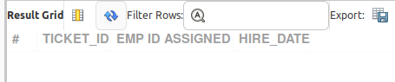

- Retrieve the latest task start date in the dataset.
SELECT MAX(`START DATE`) AS latest_task_start_date
FROM TASK;
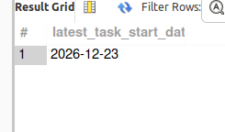
- List all tickets assigned to a specific employee along with their difficulty levels.
SELECT TICKET_ID, `DIFFICULTY LEVEL`
FROM TASK
WHERE `EMP ID ASSIGNED` = 'E.EMP_ID';
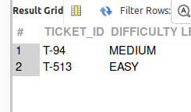

- Calculate the total number of tasks in each sprint.
SELECT SPRINT_ID, COUNT(*) AS TOTAL_TASKS
FROM TASK
GROUP BY SPRINT_ID;
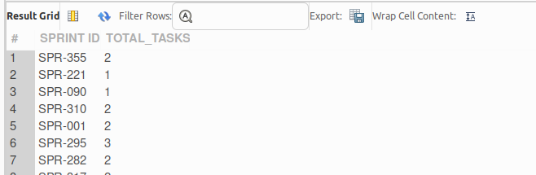
- Retrieve all employees who have been promoted (appear in the Employee Growth table).
SELECT *
FROM EMPLOYEE
WHERE `EMP_ID` IN (
SELECT `EMP ID`
FROM `EMPLOYEE GROWTH`
);
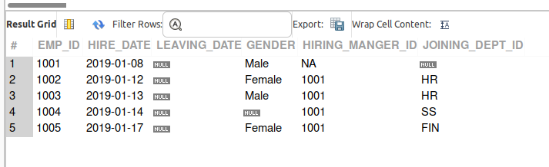

- Find the maximum salary change for any employee in the Employee Growth table.
SELECT MAX(`NEW SALARY`) AS MAX_SALARY_CHANGE
FROM `EMPLOYEE GROWTH`;
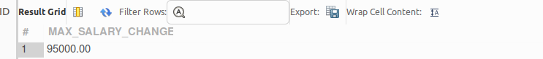
- Identify employees who changed departments and their new department IDs.
SELECT E.`EMP_ID`, EG.`NEW DEPT ID`
FROM EMPLOYEE E
JOIN `EMPLOYEE GROWTH` EG
ON E.`EMP_ID` = EG.`EMP ID`
WHERE E.`JOINING_DEPT_ID` <> EG.`NEW DEPT ID`;
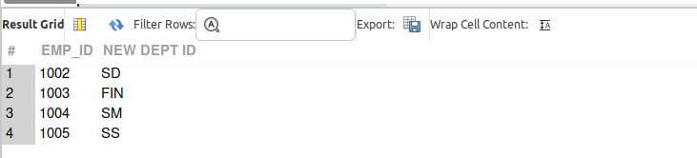
- Find projects that have not started but have associated sub-projects marked as "Completed."
SELECT DISTINCT P.`PROJECT ID`
FROM PROJECTS P
JOIN `SUB PROJECTS` SP
ON P.`PROJECT ID` = SP.`PROJECT ID`
WHERE P.STATUS = 'NOT STARTED'
AND SP.STATUS = 'COMPLETED';
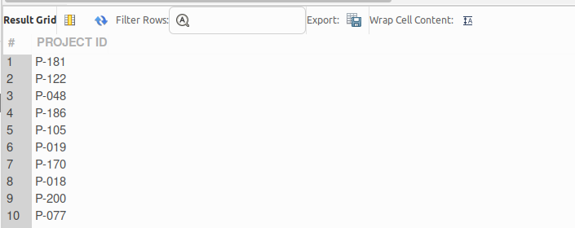
- List all managers who handle sub-projects with "In Progress" status.
SELECT DISTINCT `MANAGER ID`
FROM `SUB PROJECTS`
WHERE STATUS = 'IN PROGRESS';
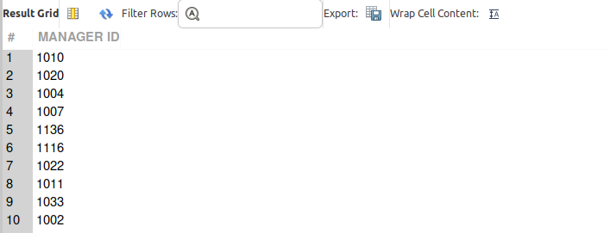

- Calculate the average time taken to complete a task for each project.
SELECT `PROJECT ID`,
AVG(DATEDIFF(`END DATE`, `START DATE`)) AS AVG_TASK_DAYS
FROM TASK
WHERE STATUS = 'COMPLETED'
GROUP BY `PROJECT ID`;

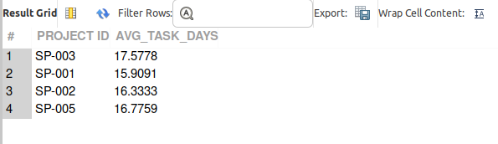

- Identify sprints that include tasks from multiple projects.
SELECT `SPRINT ID`
FROM TASK
GROUP BY `SPRINT ID`
HAVING COUNT(DISTINCT `PROJECT ID`) > 1;
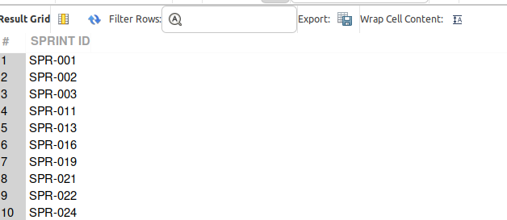

- Retrieve the total number of employees working on each project.
SELECT `PROJECT ID`, COUNT(DISTINCT `EMP ID ASSIGNED`) AS TOTAL_EMPLOYEES
FROM TASK
GROUP BY `PROJECT ID`;
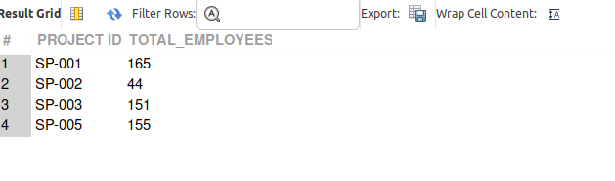
- Find the total number of tasks in "On Hold" status for each sprint.
SELECT `SPRINT ID`, COUNT(*) AS TOTAL_ON_HOLD_TASKS
FROM TASK
WHERE STATUS = 'ON HOLD'
GROUP BY `SPRINT ID`;
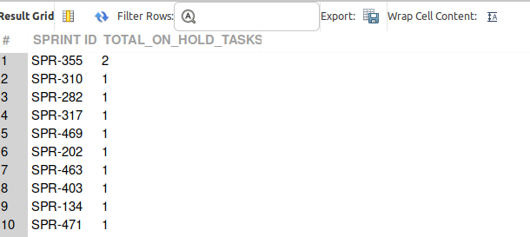

- Identify employees who were hired before 2020 and are still active.
SELECT EMP_ID, HIRE_DATE
FROM EMPLOYEE
WHERE HIRE_DATE < '2020-01-01'
AND LEAVING_DATE IS NULL;
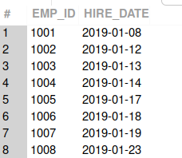

- Retrieve the list of projects and the count of associated sub-projects.
SELECT P.`PROJECT ID`, COUNT(S.SUB_PRO_ID) AS sub_project_count
FROM PROJECTS P
LEFT JOIN SUB_PROJECTS S
ON P.`PROJECT ID` = S.PROJECT_ID
GROUP BY P.`PROJECT ID`;
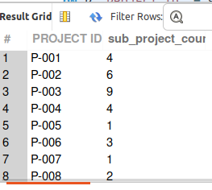
- Find the average salary of employees in each department.
SELECT `NEW DEPT ID`, AVG(`NEW SALARY`) AS avg_salary
FROM `EMPLOYEE GROWTH`
GROUP BY `NEW DEPT ID`;
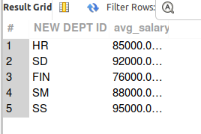
- List employees who have reported the highest number of tickets.
SELECT TICKET_REPORTEE, COUNT(*) AS total_tickets
FROM TASK
GROUP BY TICKET_REPORTEE
ORDER BY total_tickets DESC;
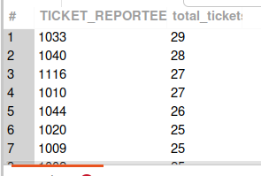

- Identify the department with the highest number of completed tasks.
SELECT E.JOINING_DEPT_ID, COUNT(*) AS completed_tasks
FROM TASK T
JOIN EMPLOYEE E
ON T.`EMP ID ASSIGNED` = E.EMP_ID
WHERE T.STATUS = 'COMPLETED'
GROUP BY E.JOINING_DEPT_ID
ORDER BY completed_tasks DESC
LIMIT 1;
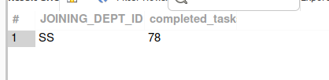
- Calculate the average duration (in days) of all tasks.
SELECT AVG(DATEDIFF(`END DATE`, `START DATE`)) AS avg_task_duration_days
FROM TASK;
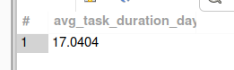
- List all employees who reported tickets with "High" priority levels.
SELECT DISTINCT TICKET_REPORTEE
FROM TASK
WHERE `PRIORITY LEVEL` = 'HIGH';
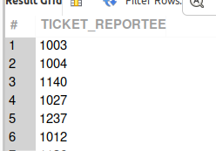
- Retrieve all projects and the total number of tasks associated with each.
SELECT `PROJECT ID`, COUNT(TICKET_ID) AS total_tasks
FROM TASK
GROUP BY `PROJECT ID`;
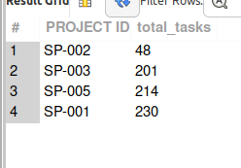
- Find all departments that currently have no employees.
SELECT D.`DEPT ID`, D.`DEPT NAME`
FROM DEPARTMENT D
LEFT JOIN EMPLOYEE E
ON D.`DEPT ID` = E.JOINING_DEPT_ID
WHERE E.EMP_ID IS NULL;
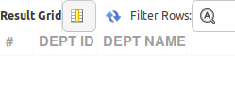
- Identify employees who were assigned tasks in multiple sprints.
SELECT `EMP ID ASSIGNED`, COUNT(DISTINCT `SPRINT ID`) AS sprint_count
FROM TASK
GROUP BY `EMP ID ASSIGNED`
HAVING COUNT(DISTINCT `SPRINT ID`) > 1;
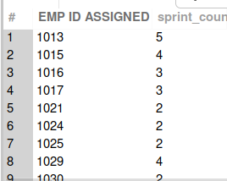
- Use a recursive CTE to identify the hierarchy of sub-projects under a specific project.
WITH RECURSIVE SUB_PROJECT_HIERARCHY AS (
SELECT `SUB PRO ID`, `PROJECT ID`
FROM `SUB PROJECTS`
WHERE `PROJECT ID` = 'P-001'

UNION ALL

SELECT SP.`SUB PRO ID`, SP.`PROJECT ID`
FROM `SUB PROJECTS` SP
JOIN SUB_PROJECT_HIERARCHY SH
ON SP.`PARENT SUB PROJECT ID` = SH.`SUB PRO ID`
)
SELECT * FROM SUB_PROJECT_HIERARCHY;

-- 42
SELECT
`EMP ID`,
`DATE`,
`NEW SALARY`,
AVG(`NEW SALARY`) OVER (
PARTITION BY `EMP ID`
ORDER BY `DATE`
ROWS BETWEEN 2 PRECEDING AND CURRENT ROW
) AS MOVING_AVG_SALARY
FROM `EMPLOYEE GROWTH`;
- Calculate a moving average of salaries for employees in the Employee Growth table.
SELECT
`EMP ID`,
`DATE`,
`NEW SALARY`,
AVG(`NEW SALARY`) OVER (
PARTITION BY `EMP ID`
ORDER BY `DATE`
ROWS BETWEEN 2 PRECEDING AND CURRENT ROW
) AS MOVING_AVG_SALARY
FROM `EMPLOYEE GROWTH`;
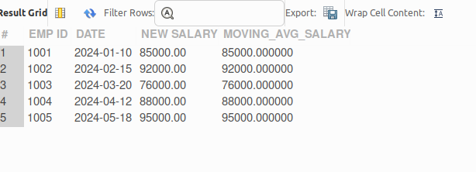
- Rank departments by the total number of active employees using a ranking function.
SELECT
E.`JOINING DEPT ID`,
COUNT(E.`EMP ID`) AS TOTAL_EMPLOYEES,
RANK() OVER (ORDER BY COUNT(E.`EMP ID`) DESC) AS DEPT_RANK
FROM EMPLOYEE E
WHERE E.`LEAVING DATE` IS NULL
GROUP BY E.`JOINING DEPT ID`;
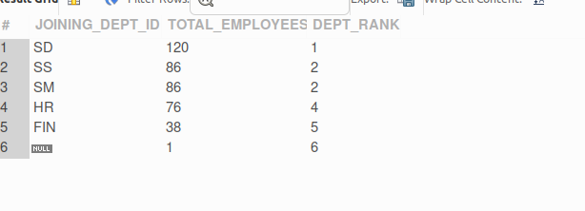
- Find the percentage of tasks completed for each project using a window function.
SELECT DISTINCT
`PROJECT ID`,
SUM(CASE WHEN STATUS = 'COMPLETED' THEN 1 ELSE 0 END)
OVER (PARTITION BY `PROJECT ID`) * 100.0
/ COUNT(*) OVER (PARTITION BY `PROJECT ID`)
AS COMPLETION_PERCENTAGE
FROM TASK;
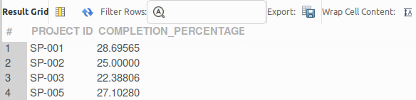

- Identify project leads managing the most "In Progress" projects.
SELECT
`PROJECT LEAD ID`,
COUNT(*) AS in_progress_count
FROM PROJECTS
WHERE STATUS = 'IN PROGRESS'
GROUP BY `PROJECT LEAD ID`
ORDER BY in_progress_count DESC;
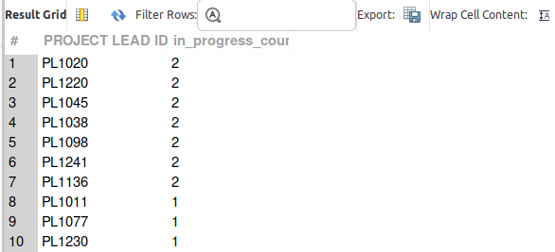
- Calculate the rolling average task completion time for each project using a window function.
SELECT
TICKET_ID,
`PROJECT ID`,
DATEDIFF(`END DATE`, `START DATE`) AS COMPLETION_TIME,
`END DATE` AS COMPLETION_DATE,
AVG(DATEDIFF(`END DATE`, `START DATE`)) OVER (
PARTITION BY `PROJECT ID`
ORDER BY `END DATE`
ROWS BETWEEN 2 PRECEDING AND CURRENT ROW
) AS rolling_avg_completion
FROM TASK
ORDER BY `PROJECT ID`, `END DATE`;
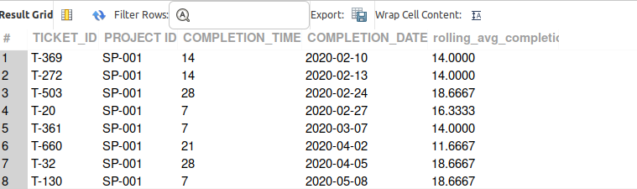

- Rank tasks within each sprint by difficulty level using a ranking function.
SELECT
`SPRINT ID`,
`DIFFICULTY LEVEL`,
RANK() OVER (
PARTITION BY `SPRINT ID`
ORDER BY `DIFFICULTY LEVEL` DESC
) AS difficulty_rank
FROM TASK
ORDER BY `SPRINT ID`, difficulty_rank;
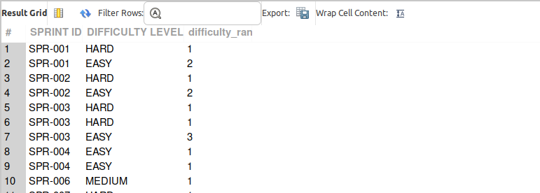

- Identify projects that have the longest average task duration.
SELECT
`PROJECT ID`,
AVG(DATEDIFF(`END DATE`, `START DATE`)) AS avg_task_duration
FROM TASK
GROUP BY `PROJECT ID`
ORDER BY avg_task_duration DESC
LIMIT 1;
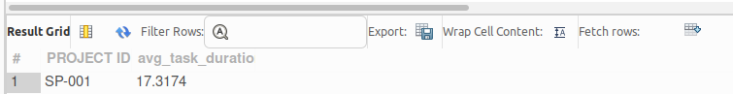
- Find the department with the highest number of ongoing projects.
SELECT
`DEPT ID`,
COUNT(*) AS ongoing_projects
FROM PROJECTS
WHERE STATUS = 'IN PROGRESS'
GROUP BY `DEPT ID`
ORDER BY ongoing_projects DESC
LIMIT 1;
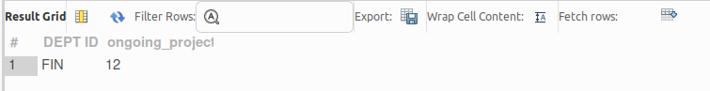

- Use a window function to find the latest promotion date for each employee.
WITH ranked_promotions AS (
SELECT
`EMP ID`,
`NEW DESIGNATION`,
`DATE`,
ROW_NUMBER() OVER (
PARTITION BY `EMP ID`
ORDER BY `DATE` DESC
) AS rn
FROM `EMPLOYEE GROWTH`
)
SELECT
`EMP ID`,
`NEW DESIGNATION` AS latest_designation,
`DATE` AS latest_promotion_date
FROM ranked_promotions
WHERE rn = 1;

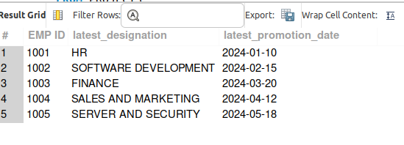

- Retrieve the total number of tickets reported by each employee, ranked in descending order.
SELECT
e.EMP_ID,
e.EMP_ID AS Employee_ID,
COUNT(t.TICKET_ID) AS Total_Tickets_Reported,
RANK() OVER (ORDER BY COUNT(t.TICKET_ID) DESC) AS Ticket_Rank
FROM
EMPLOYEE e
LEFT JOIN
TASK t
ON e.EMP_ID = t.TICKET_REPORTEE
GROUP BY
e.EMP_ID
ORDER BY
Total_Tickets_Reported DESC;

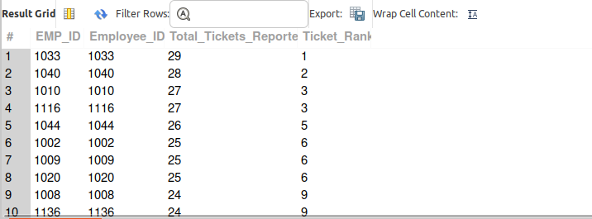

- Find the top 3 employees based on the number of tasks they have been assigned.
SELECT
e.EMP_ID,
COUNT(t.TICKET_ID) AS Total_Tasks_Assigned,
RANK() OVER (ORDER BY COUNT(t.TICKET_ID) DESC) AS Task_Rank
FROM
EMPLOYEE e
LEFT JOIN
TASK t
ON e.EMP_ID = t.`EMP ID ASSIGNED`
GROUP BY
e.EMP_ID
ORDER BY
Total_Tasks_Assigned DESC
LIMIT 3;
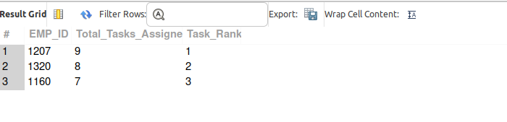
- Calculate the percentage increase in salary for each employee over their promotion history.
SELECT
emp.EMP_ID,
eg.`DATE` AS Promotion_Date,
eg.`NEW SALARY`,
LAG(eg.`NEW SALARY`) OVER (PARTITION BY emp.EMP_ID ORDER BY eg.`DATE`) AS Previous_Salary,
CASE
WHEN LAG(eg.`NEW SALARY`) OVER (PARTITION BY emp.EMP_ID ORDER BY eg.`DATE`) IS NULL THEN NULL
ELSE ROUND(
((eg.`NEW SALARY` - LAG(eg.`NEW SALARY`) OVER (PARTITION BY emp.EMP_ID ORDER BY eg.`DATE`))
/ LAG(eg.`NEW SALARY`) OVER (PARTITION BY emp.EMP_ID ORDER BY eg.`DATE`)) * 100, 2)
END AS Percentage_Increase
FROM
`EMPLOYEE GROWTH` eg
JOIN
EMPLOYEE emp
ON emp.EMP_ID = eg.`EMP ID`
ORDER BY
emp.EMP_ID,
eg.`DATE`;
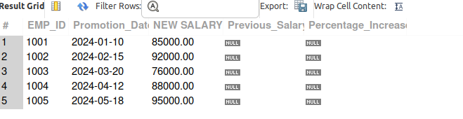
- Use a recursive CTE to list all sub-projects under a project recursively with their status.
WITH RECURSIVE SubProjectHierarchy AS (
-- Anchor member: start with the main project
SELECT
sp.`SUB PRO ID`,
sp.`PROJECT ID`,
sp.STATUS,
1 AS Level
FROM
`SUB PROJECTS` sp
WHERE
sp.`PROJECT ID` = 101

UNION ALL

-- Recursive member
SELECT
sp.`SUB PRO ID`,
sp.`PROJECT ID`,
sp.STATUS,
sph.Level + 1 AS Level
FROM
`SUB PROJECTS` sp
INNER JOIN
SubProjectHierarchy sph
ON sp.`PROJECT ID` = sph.`SUB PRO ID`
)
SELECT
`SUB PRO ID`,
`PROJECT ID`,
STATUS,
Level
FROM
SubProjectHierarchy
ORDER BY
Level, `SUB PRO ID`;
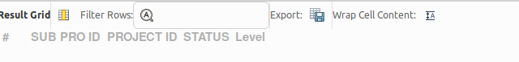
- Identify sprints that overlap with specific project timelines.
SELECT
p.`PROJECT ID`,
s.SPRINT_ID,
p.`START DATE` AS project_start,
p.`END DATE` AS project_end,
s.`START DATE` AS sprint_start,
s.`END DATE` AS sprint_end
FROM PROJECTS p
JOIN SPRINT s
ON s.`START DATE` <= p.`END DATE`
AND s.`END DATE` >= p.`START DATE`
ORDER BY p.`PROJECT ID`, s.`START DATE`;
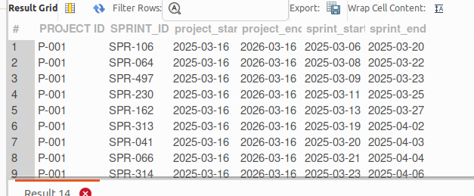
- Calculate the average difficulty level of tasks within each priority level using window functions.
SELECT
TICKET_ID,
`PRIORITY LEVEL`,
`DIFFICULTY LEVEL`,
AVG(`DIFFICULTY LEVEL`) OVER (PARTITION BY `PRIORITY LEVEL`) AS avg_difficulty_by_priority
FROM TASK
ORDER BY `PRIORITY LEVEL`, TICKET_ID;
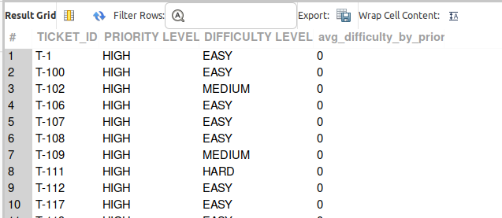

- Rank sprints based on the total number of tasks completed.
SELECT
s.SPRINT_ID,
COUNT(t.TASK_ID) AS total_completed_tasks,
RANK() OVER (ORDER BY COUNT(t.TASK_ID) DESC) AS sprint_rank
FROM SPRINTS s
LEFT JOIN TASKS t
ON s.SPRINT_ID = t.SPRINT_ID
AND t.STATUS = 'Completed'
GROUP BY s.SPRINT_ID
ORDER BY sprint_rank;

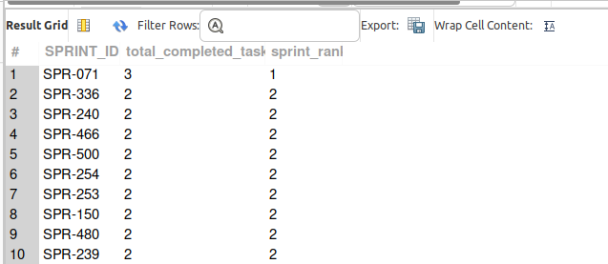
- Retrieve the project that has the highest number of associated tasks.
SELECT
`PROJECT ID`,
total_tasks
FROM (
SELECT
`PROJECT ID`,
COUNT(TICKET_ID) AS total_tasks
FROM TASK
GROUP BY `PROJECT ID`
) AS sub
ORDER BY total_tasks DESC
LIMIT 1;
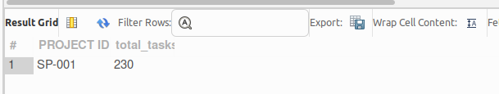

- Calculate the total working days for tasks in each sprint, grouped by project.
SELECT
`PROJECT ID`,
`SPRINT ID`,
SUM(DATEDIFF(`END DATE`, `START DATE`) + 1) AS total_working_days
FROM TASK
GROUP BY `PROJECT ID`, `SPRINT ID`
ORDER BY `PROJECT ID`, `SPRINT ID`;
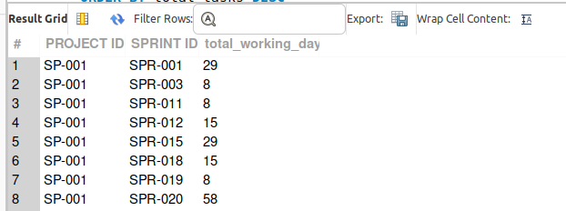
- Use a ranking function to identify the top 5 departments based on the number of completed projects.
WITH RankedDepts AS (
SELECT
`DEPT ID`,
COUNT(*) AS completed_projects,
RANK() OVER (ORDER BY COUNT(*) DESC) AS dept_rank
FROM PROJECTS
WHERE STATUS = 'COMPLETED'
GROUP BY `DEPT ID`
)
SELECT
`DEPT ID`,
completed_projects,
dept_rank
FROM RankedDepts
WHERE dept_rank <= 5;

